

**Capitalism without capital: understanding our new "knowledge" economy**

Speech given by Professor Jonathan Haskel, External Member of the Monetary Policy Committee

Ken Dixon Economics Lecture at University of York 16 May 2019

I am grateful to Jamie Lenney and Srdan Tatomir for their excellent assistance with the speech and to colleagues at the Bank of England from whom I received invaluable comments. Much of this material is drawn from joint work with

Stian Westlake, Carol Corrado, Cecilia Jona-Lasinio and Massimiliano Iommi to whom I am of course also very grateful. Errors and opinions are my own.

All speeches are available online at [www.bankofengland.co.uk/publications/speeches](http://www.bankofengland.co.uk/publications/speeches)

# Rowntree is more than just a confectionery factory.

It is an honour to have been invited to give the Ken Dixon lecture at the University of York this year on the topic of the intangible economy.

It has been a pleasure to spend time on the campus talking to students as well as to spend time talking to businesses in the region today. I also want to thank Ken Dixon for his support for the University for many years.

Today I will talk about a new type of economy. But one, as it turns out, that should be familiar to him.

Perhaps some of you might know that Ken Dixon worked for a British confectionery company, Rowntree Mackintosh. Rowntree was founded in York in 1725 by a cocoa and chocolate vendor who sold the business to the Rowntree family in 1862. Later, in 1970, Rowntree merged with John Mackintosh & Sons. You might be

familiar with some of Rowntree’s brands such as: Fruit Gums, Quality Street, KitKat, Aero, After Eights, etc. The old factory was based on Haxby Road, just a 15 minutes’ drive from the University. What made Rowntree

particularly successful, though, was not just the production of chocolate but the value of its brands.

In 1981, Ken Dixon was appointed chairman and CEO of Rowntree Mackintosh. At the time, Rowntree wasn’t doing so well. Its profitability was down compared to the mid-1970s. Mr Dixon started a long-term programme to turn Rowntree around. He invested £400 million to improve manufacturing efficiency and upgrade capacity so

that Rowntree could produce greater volumes of KitKats and Smarties. But Mr Dixon also invested substantially in brand development. Rowntree was very successful at using marketing to develop its brands (Fitzgerald, 2007). According to Mr Dixon: ‘*The fundamental idea which drives Rowntree is branding, the creation of distinct, differentiated, positively identifiable and market positioned goods.*’ (Hyde, Ellert and Killing, 1991).

Thus, Rowntree’s success was not just due to its use of production methods and facilities but also due to the value of brands which fostered customer loyalty and generated future demand for its products. The value of Rowntree’s assets was not just the buildings and machines it owned and used to produce confectionery. It was also something less tangible, the value of its brand names. Nestle recognised the value of Rowntree’s brands and this is why when it took Rowntree over in 1988 the price it paid for the company exceeded tangible assets by 300% (Nielsen, 1993). This price represented more than double of Rowntree’s pre-bid market capitalisation (Mather and Peasnell, 1991).

What Rowntree’s story tells us is that the value of companies and the value of their assets is not just what we can see. It is also what is less visible but still gives companies the ability to generate profits over many years. Nestlé today is a major corporation. It owns many factories but is also owns numerous brands and invests in both brand development and scientific research and development (R&D). For example, Nestlé’s factory still produces KitKats on Haxby Road but Nestlé also continues to operate a R&D centre in York developing new technologies and innovative products.

Today, I will talk about how our economies have changed, the role of intangible capital and intangible investment and why that matters for understanding how firms behave differently than in the past.

# Not all investments are things you can touch.

My book with Stian Westlake is titled ‘Capitalism without Capital’ but if there is no capital how does this even make sense? In our view, to understand the world today it is important to make a distinction between tangible and intangible capital. Let me illustrate with some examples that might better explain what we mean by tangible and intangible capital and why economies have shifted towards intangible capital.

In 2018, some of the world’s largest companies by market capitalisation were Apple, Alphabet, Microsoft,

Amazon and Tencent (Table 1). When you look at their balance sheets, they actually had very little tangible capital. For example, Microsoft only had $5bn worth of tangible capital in 2016 but $85bn worth1 of R&D capital.

Alphabet (Google) has $20bn of tangible capital but $53bn of R&D capital in the same year. Why are their tangible assets so small relative to their market value? What is going on?

## Table 1 – Top 10 global companies by market capitalisation

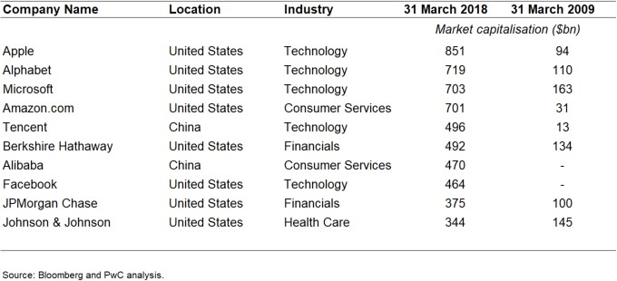

Tangible assets are the values of buildings, equipment and vehicles. These are the assets that accountants can measure well. But a moment’s reflection on the companies will convince you that their business relies very little on such assets. Rather, their assets are software, reputation, relationships and knowledge. That is, they are intangible assets. These assets are called, by economists, capital assets or capital for short. A capital asset is something owned by the firm that gives it a long-lived (more than a year) stream of services that it can use in production. A machine or building or vehicle is a tangible capital asset, or tangible capital. Knowledge from R&D, software, reputation and brands are also assets but intangible.

So, what do the accounts say about these? Well, they say very little since the rules for reporting intangible assets are mixed. Broadly speaking, firms don’t have to report them. If you do a lot of digging in company accounts you might find reported figures for spending on R&D. But even then the figure is small. That’s

1 These are the cumulated values of reported expenditure on R&D since the companies began.

because R&D doesn’t capture a lot of their activities. The fact illustrated above, that these leading companies work with very little measured capital, explains the title of our book. Namely, business for them can be described as capitalism without capital.

# Tangible and intangible capital

Table 2 sets out the capital we are talking about. On the left are the tangible business investments: buildings,

ICT equipment like computer hardware, non-ICT equipment and vehicles. On the right are intangibles: software, databases, design, mineral exploration, R&D, and business processes, for example. These intangibles in the right column are those elements of spending that business and national accountants have been reluctant to count as investment although over the last forty years some of them have been included as such.

## Table 2 – Classification of Tangible and Intangible Investment

**Tangible Investment Intangible investment**

Building and structures Computerised information IT equipment (hardware, communication) Software

Non-computer equipment Databases

Vehicles *Innovative property*

R&D and mineral exploration Artistic originals

Design

*Economic Competencies*

Training

Market research and branding

Business process re-engineering

Intangible assets are different than tangible assets in important ways. Intangible assets have, in our view, four distinct properties that make them different to tangible assets. These are: scalability, sunkenness, spill-overs and synergies. Let me explain these in more detail.

*Scalability*

Physical assets can only be in one place at one time. Intangible assets, by contrast, can usually be used over and over, in multiple places at the same time. For example, once you’ve written the Starbucks operating manual in Chinese, an investment in organizational development, you can use it in each of the country’s 1,200-plus stores. The costs of developing the app Angry Birds, an investment in software, can be spread over an arbitrarily large number of downloads. Once a business has created or acquired an intangible asset, it can make use of it again and again at relatively little cost, compared to most physical assets.

*Sunk costs*

If a business makes an intangible investment and later on decides it wants to back out, it’s often hard to reverse the decision and try to get back the investment’s cost by selling the created asset – and, in general, it’s harder

than in the case of a tangible asset. Economists describe these kinds of irrecoverable costs as “sunk”. For example, if a logistics company goes bankrupt its creditors can sell transport vans and warehouses to pay off its

outstanding debts. These assets can be put to use in different companies and/or different industries and there is often an active and liquid market that trades in them. But creditors might find it more difficult to sell intangible assets such as specialised logistics software or the firm’s brand name.

*Spillovers*

Some intangible investments have unusually high spillovers, that is to say, it is relatively easy for other businesses to take advantage of intangible investments they don’t themselves make. The classic example is R&D. Copying other people’s ideas is relatively easy, unless the law prevents it by means of patents or copyrights. In the language of economists, the ideas created by R&D are non-rival; my using a piece of knowledge doesn’t prevent you from also using it. In Thomas Jefferson’s words, “*He who receives an idea from me, receives instruction himself without lessening mine; as he who lights his taper at mine, receives light without darkening me.*” (Lipscomb and Bergh, 1905).

But spillovers don’t just arise from R&D. After Apple released the iPhone, almost all smartphones started looking just like it. Apple’s investments in software, design, and supply chains were adopted or imitated by its competitors as they sought to create phones like Apple’s. This is an example of marketing spillovers. Perhaps less obviously, there are also spillovers in organizational design, training, and branding and marketing.

*Synergies*

Ideas and other ideas go well together. This is especially true in the field of technology. For example, the microwave oven relied on technology that was invented by the British in the Second World War as part of the radar defences pioneered to defend its shores. Intangible investments, in particular information technologies and especially networked computers and smartphones, also show synergies with tangible assets. For example, in the 1990s Walmart used computers and software to reorganize their supply chains, improves efficiency and lower prices. It used organisational and business practices in combination with new technologies to improve productivity.

# Trends in the economy as a whole

As discussed above, these intangibles are not counted in company accounts so we cannot get comprehensive data for a company. But we can for economies as a whole. To do so, we have to use some detective work to find them out, relying on various surveys (e.g. training surveys), input-output tables and the fact that national accounts include some intangibles. When we do this, what do we find?

These data are drawn from the work I have done with Carol Corrado, Cecilia Jona-Lasinio and Massimiliano Iommi that have produced harmonized2 national estimates that include the United States, called the

INTAN-Invest dataset3, covering the economies of 20 European countries and the United States up to 2016.

2 Harmonised" means that, to the extent possible, the same concepts, methods, and data sources are applied and used for each country.

3 For more details please refer to [www.intaninvest.net.](http://www.intaninvest.net/)

Let’s start with the United States (US) and Europe where Europe is the following EU countries for whom we have data: Austria (AT), Germany (DE), Denmark (DK), Spain (ES), Finland (FI), France (FR), Italy (IT),

Netherlands (NL), Sweden (SE), and United Kingdom (UK). Figures 1 and 2 show data for these countries for which we have a broader set of measures on intangible investment. Figure 3 displays a wider group of countries for an extended cross-country comparison.

Figure 1 shows data on the intangible and tangible investment shares of aggregate value added in Europe and the United States. As may be seen, intangible investment overtook tangible investment before the global

financial crisis, during which intangible investment fell comparatively less than tangible investment. Figure 2 breaks out the investment shares for Europe versus the United States. The US intangibles share is higher and more variable than the aggregate share for our 10 European (EU) countries. In the EU countries, though intangibles are less, the intangible investment share is steadily increasing. The tangible share declines, on balance, in both areas. Figure 1 and 2 tell us that at the level of the macroeconomy intangible investment is a big deal, and that the economies of Europe and US have shifted significantly towards these type of investments over the last few decades.

## Figure 1 – Intangible and tangible investment shares for Europe and the United States combined

|  |
| --- |
|  |
| Source: Authors’ elaboration of data from INTAN-Invest, EU KLEMS, Eurostat, and national accounts for European countries and the United States.  Note: Shares are of aggregate market sector GVA including all intangibles. |

**Figure 2 – Intangible and tangible investment shares of output**

|  |
| --- |
| (a) Europe (left) versus the United States (right) |
| Source: Authors’ elaboration of data from INTAN-Invest, EU KLEMS, Eurostat, and national accounts for European countries and the United States.  Note: Shares are of aggregate market sector GVA including all intangibles. |

**Figure 3 – Intangible and tangible investment shares of output**

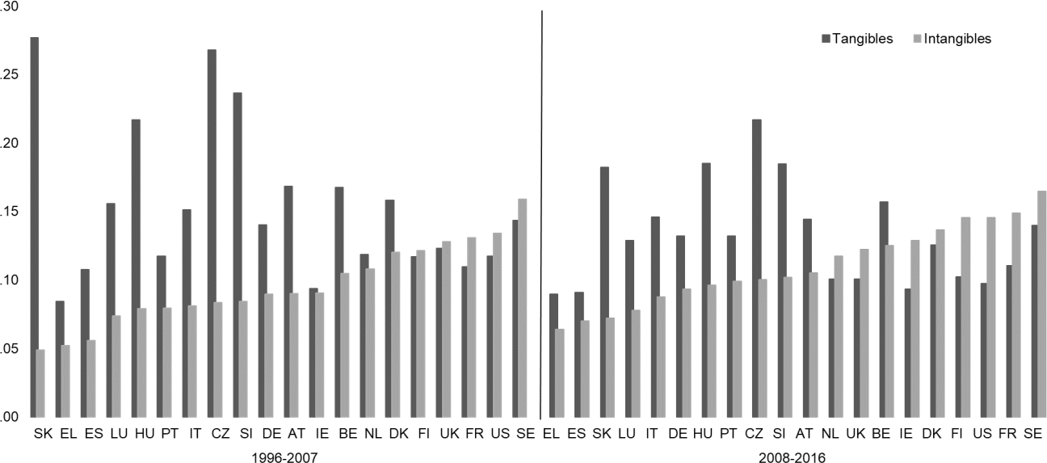

Note: GDP is adjusted to include intangibles. Country abbreviations are as follows: Austria (AT), Belgium (BE), Czech Republic (CZ), Germany (DE), Greece (EL), (GR), Denmark (DK), Hungary (HU), Spain (ES), Finland (FI), France (FR), Ireland (IE), Italy (IT), Luxembourg (LU), Netherlands (NL), Portugal (PT), Slovenia (SI), Slovakia (SK), Sweden (SE), United Kingdom (UK), United States (US).

Source: Authors' elaboration of data from INTAN-Invest@2018.

There is a good deal of variation across countries as shown in Figure 3 which shows the tangible and intangible investment shares of GDP (adjusted to include intangibles) for the 20 INTAN-Invest economies averaged over years before and after the global financial crisis (1996 to 2007) and (2008 to 2016) (tangible investment excludes residential structures). Intangible shares of GDP vary from 6 and 7 percent to 15 and 16 percent for

the two lowest and two highest in the latter period. The US and Sweden are consistently high. Intangible shares are slightly higher after the crisis, but tangible shares are mostly down. Figure 3 is sorted left to right by the

intangible share of output. This highlights that the lower intangible share economies are also the higher tangible share economies (e.g. Slovakia), and that the inclusion of intangible investment lowers the coefficient of variation4 of countries investment ratios to GDP.

# Some implications

There are at least three major avenues through which I think the secular increase in intangible capital matters for the economy and policymakers. These are: the measurement of investment and capital, how intangibly

intensive firms finance5 themselves, and finally implications for capacity constraints.6 Today, I’d like focus on the first of these implications although I think the other implications are very important and still somewhat open questions.

So, turning to measurement and without knowing anything about the economic properties of intangibles, one can right away get some feel for how they change things by looking at the accounting definitions of value added and profits.

Measuring and decomposing output

*Value added*

To count the output of an economy producing steel and cars you might think of adding up the production of all the steel and all the cars. That would, of course, be wrong since the value of the cars includes some of the steel. What Value Added (or GDP) does is to subtract any inputs that get used up and transformed in the process of production, these are called intermediate inputs, and this overcomes the issue of double counting.

That raises the question of what is and isn’t an intermediate. Steel sounds like it is in this example but suppose the car company develops software such as a navigation system, for example. This same software can be used for many cars over many years and is by no means used up. The software is, therefore, a produced capital good not an intermediate input and so it should be included in value added. The car company produces both a car and a software factory.

*Wages and profits*

The creation of value added requires inputs, which economists and statistical organisations typically separate into capital and labour. The following relation between value added and payments to those inputs holds as an identity:

𝑝𝑣𝑉 = 𝑝𝐿𝐿 + 𝑝𝑘𝐾 + 𝜋 (1)

4 The coefficient of variation (𝑠𝑡𝑎𝑛𝑑𝑎𝑟𝑑 𝑑𝑒𝑣𝑖𝑎𝑡𝑖𝑜𝑛), for the 2008-2016 period excluding intangible investment is 0.27, including intangible capital

𝑚𝑒𝑎𝑛

brings the ratio down to 0.17.

5 For example, intangible capital is difficult to value and collateralise which affects risk premiums and the balance of finance between debt and equity.

6 Intangible capital is scalable and less likely to run into short run capacity constraints.

On the left we have measured nominal value added, 𝑝𝑣𝑉, where 𝑝𝑣 and 𝑉 are the price and volume of value added respectively. On the right are the payments to labour (L) and capital (K). For the purposes of this section let us call 𝑝𝐿, the rental cost of labour, the wage (we are ignoring taxes and subsidies and the self-employed).

What about payments to capital? Let us suppose that capital potentially earns two types of returns. First,

owners of capital make a return that, in a competitive market, compensates them for the risks and expenses incurred in owing capital. For example, airlines need to hire labour but also operate aircraft. In a competitive market 𝑝𝑘𝐾 is the costs they have to incur to operate that capital K. Secondly, if markets are not competitive, due to barriers to entry for an airline route say, firms might make money over and above what they have to pay to operate their planes. This is the 𝜋 term and we shall call this ‘pure profit’ above production costs.

We shall return to this below, but it turns out to be very hard to measure 𝜋 independently. Thus for now, let us assume we measure 𝑝𝑣𝑉 and 𝑝𝐿𝐿 and then ascribe all the rest to the firm’s tangible capital payments, this means we can write:

𝑝𝑣𝑉 = 𝑝𝐿𝐿 + 𝑝𝑉 𝐾𝑇 (2)

𝑘,𝑇

Where we subscript 𝑝𝑣 and 𝐾 with a T to denote tangible capital and therefore intangibles are being excluded. Where do intangibles fit in? When we include intangibles we add two things. First, we have a new and higher value added, 𝑝𝑄𝑄 : the company producing the cars is producing value added in both cars and also software.

𝑘,𝑇

Second, we have more capital 𝐾𝐼, since there is a capital stock of software. Thus we define:

𝑝𝑄𝑄 = 𝑝𝐿𝐿 + 𝑝𝑄 𝐾𝑇 + 𝑝𝑄 𝐾𝐼 (3)

𝑘,𝑇 𝑘,𝐼

It should be immediately obvious that the conventional measurements might give a misleading picture of the economy. Compare, for example, the capital shares under each measure 𝑄 and 𝑉 which we can write as:

𝑠𝐾,𝑉

𝑝 𝑉 𝐾𝑇

=

𝑘,𝑇

𝑝𝑣𝑉

(4)

𝑠𝐾,𝑄

𝑝𝑄 𝐾𝑇 + 𝑝𝑄 𝐾𝐼

=

𝑘,𝑇 𝑘,𝐼

𝑝𝑄𝑄

(5)

Both the numerator and denominator have changed in equation (5) and so when we account for intangibles it’s not clear if the capital share has risen or not. However, because payments to labour (𝑝𝑙𝐿) remain the same and

𝑝𝑄𝑄 is greater than 𝑝𝑉𝑉, it is in fact the case that the capital share rises when intangibles are included. What is

not clear is how the trends in the two calculated shares in equations (4) and (5) differ over time.

*Rental prices and asset prices*

We now go further by digging deeper into just what 𝑝𝑘,𝑇 and 𝑝𝑘,𝐼 actually are. In the GDP identity we want to put capital and labour on an equal footing. Now, on the left hand side is the nominal value of output, which is a flow

of value added produced over the year. What is the relevant flow of payments to labour and capital on the right hand side? It is the flow of payments to use those factors for a year. Now, for workers this is straightforward. It is the cost of hiring them over a year. For capital, it is the equivalent: the cost of hiring capital for a year, or what is called the rental cost of capital. The reason for trying to be clear about this is that capital often has two prices and not one, a rental price and an asset price. For example, I can buy a van outright for my business with the price I pay being the asset price, 𝑝𝑎, or I can rent a van for a year, at a given and presumably lower price 𝑝𝑘.

What we need is the rental price and not the asset price. There is, however, a link between the two prices

derived in a now famous work by economists Robert Hall and Dale Jorgenson (1967). Suppose you are a hire car company who buys a car for a price 𝑝𝑎, and then has to decide how much to rent it out for. That rental price would have to cover at least two things. First, you could have done something else with the money such as

putting it in some other project, for example, and earning a return 𝜌. Second, the rental will have to cover any change in the value over the rental period (depreciation, 𝛿). In a well-functioning market then, the rental price has to equal these two factors so that:

𝑝𝑘 = 𝑝𝑎(𝜌 + 𝛿) (6)

Now let us substitute equation (6) into equation (4) and (5) to get:

𝑠𝐾,𝑉 =

𝑝𝑎,𝑇(𝜌𝑉 + 𝛿𝑇) 𝐾𝑇

(7)

𝑝𝑣𝑉

𝑝𝑎,𝑇(𝜌𝑄 + 𝛿𝑇) 𝐾𝑇 + 𝑝𝑎,𝐼(𝜌𝑄 + 𝛿𝐼) 𝐾𝐼

𝑠𝐾,𝑄 =

𝑝𝑄

(8)

𝑄

Consider the top equation (7) and suppose 𝑝 , 𝛿 and 𝐾 are stable. Mechanically, a rise in 𝑠

must be

𝑎,𝑇 𝑇 𝑉

𝐾,𝑉

accompanied by a rise in 𝜌𝑉. Now looking at equation (8), a rise in 𝑠𝐾,𝑄 might be accompanied by a rise in

𝜌𝑄 but it is also possible that a rise in 𝐾𝐼, especially if 𝐾𝐼 has a high 𝛿𝐼, accounts for that rise so that 𝜌 stays the same.

Some evidence from the US and UK

We want to calculate these terms to see if 𝑠𝑘 and 𝜌 are changing, and to what extent the inclusion7 of intangibles changes our interpretation. We can do this using our INTAN-Invest dataset. Figure 4 shows these values calculated for the US and UK. In the case of the US we see that the capital share of national income (Panel A) has been rising over time, just slightly less than 8 percentage points between 1998-2016 when excluding intangible investment or 5 percentage points when including it. This rise in the capital share as we’ve learnt could come from a number of sources: substitution from labour to capital, increasing depreciation rates or

increasing returns (profits). Panel B helps shed some light on this by plotting an estimate of 𝜌 over the same period for the US where intangibles are included and excluded. Interestingly, we see that the conclusions one would reach about the rise in the labour share are significantly affected by the inclusion of intangibles. When intangibles are omitted one could account for the rising capital income share as almost entirely a rise in 𝜌, that

7 Note national accounts now include some intangibles like R&D. For example R&D has been capitalised and included in the UK national accounts since 2014. Figure 4 excludes all intangibles and compares the results to output figures that incorporate a wider range of intangibles than available in national accounts.

is, returns unrelated to the cost of purchasing capital goods and their depreciation. In the intangible case, however, this result is negated as these higher returns are brought down by payments to the intangible stock of capital. Turning to the UK (panels C and D), things are different. The capital income share in both cases is relatively flat and appears to have declined somewhat from the late nineties and this is similar for the measured rates of return.

## Figure 4 - Capital income shares and rates of return for the US and UK

|  |  |
| --- | --- |
| C:\Users\330437\AppData\Local\Microsoft\Windows\INetCache\Content.Word\capincshrs_us.png  Panel A: Capital share of income (US) | N:\MPC\JonathanHaskel\Presentations\2019\KenDixon\rho_us.png  Panel B: Rate of return 𝜌 (US) |
| C:\Users\330437\AppData\Local\Microsoft\Windows\INetCache\Content.Word\capincshrs_uk.png  Panel C: Capital share of income (UK) | N:\MPC\JonathanHaskel\Presentations\2019\KenDixon\rho_uk.png  Panel D: Rate of return 𝜌 (UK) |
| Source: INTAN-Invest database.  Note: Capital income shares are calculated in accordance with equations (4) and (5). Rates of return 𝜌 are the implied rates of return based on equations (7) and (8). Results are for the market sector only and further exclude the real estate and agriculture sector. In the dashed line that excludes intangibles, all intangibles are excluded including intangibles now incorporated in official national accounts. More methodological details are available in  Corrado, Jager and Jona-Lasinio, (2016). Last data point is 2016. | |

Mark-ups

The flat returns depicted in Figure 4 and flat capital shares for the UK seem to be at some contrast to a growing literature8 that suggests that mark-ups have risen dramatically over past decades. So, what is going on? 9 A mark-up is defined as a good’s price relative to its marginal production costs, where the marginal cost (MC) for a firm is the cost to them of creating an additional incremental unit.

𝜇 =

𝑝𝑦

𝑀𝐶

(9)

That cost is not easy to calculate because it depends crucially on your definition of incremental. For a conventional factory trying to accommodate week-by-week changes in demand incremental might mean, for example, the cost of extra production when workers work overtime. In the longer run, such a firm can presumably adjust both hours of work and the capacity of the factory in which case incremental would be costs of adding another team of workers on a new production line. For the software company the short-run costs of selling another unit is essentially zero since any number of users can simply download the program but in the medium term software companies typically have to rewrite versions of their software in which case the costs are not zero.

Direct observation of marginal costs is therefore difficult and so the economics profession has gone about it in different ways. One method is to use company data and compare, by using statistical methods, the (proportional) change in output across a sample of firms with their (proportional) change in inputs. Economic

theory tells you that such a change equals the mark-up multiplied by the share of that input in total costs and if one knows the share, again from the accounts, one can work out the mark-up. Since this lecture is supposed to be of a relatively non-technical nature I hope my audience will forgive me if I defer the discussion of the

technical details of this procedure to another day. Suffice it to say a big issue in this work is the extent to which such procedures fully measure the range of costs that should be regarded as incremental. If some are left out of the analysis it might over-attribute explanatory power to those left in, leading to possibly erroneous measures of mark-ups and inferences concerning the evolution of market power. As we have seen, many intangibles are omitted from company accounts so intangibles seems like a plausible omitted variable.

Doing a little more theory, a standard relation in microeconomics is that the ratio of average cost (AC) to marginal costs equals returns to scale 𝛼:

𝛼 =

𝐴𝐶

𝑀𝐶

(10)

8 See De Loecker and Eeckhout (2017), Hall (2018) for US or Aquilante et al (2019) for UK.

9 See Syverson (2019) for a detailed consideration and explanation around these trends.

Substituting in equation (9) and noting 𝐴𝐶 = 𝐶, we redefine scale as:

𝑌

𝛼 = 𝜇

𝐶

𝑝𝑦𝑌

(11)

where C is the total costs of production, 𝑝𝑦 is the output price and Y is output. Now those costs of production are the costs of labour and capital (tangible and intangible) that are incurred in production, and in the approach above, we assumed that such costs equalled revenues. If firms are making additional revenues above

production costs we can add this to equation (11) and write an equation for the mark-up over marginal production costs as:

𝜇 =

𝛼

1 − 𝑠𝜋

(12)

where 𝑠𝜋

is the share of revenue that is profit above the costs of production, 𝑠𝜋

= 𝜋 . Equation (12) says that

𝑝𝑣𝑉

large mark-ups are reflected, other things equal, in large 𝑠𝜋, or that firms with high economies of scale 𝛼, again other things equal, will make high mark-ups. This seems consistent with the intangibles story.

Ongoing intangible activities such as software development, research and process innovation can all produce considerable returns to scale. Therefore, these measured mark-ups could be reflecting a rise in the mean level of returns to scale. However, a rise large enough to account for the dramatic rise in mark-ups measured in, for example, De Loecker *et al* (2018) seems unlikely at the level of the macroeconomy and has not been measured to date.

Other intangible activities like marketing and brand management while not increasing scale may lead to higher market and pricing power and so greater 𝑠𝜋. Indeed, a fairly large rise in 𝑠𝜋 has been reported in the US by

Barkai (2016) 10. Does this increased 𝑠𝜋 represent ‘pure profits’? Consider branding, a firm’s brand or reputation may enable it to charge a mark-up and provide the appearance of abnormal profits. However, if firms incur costs to maintain their position in the market and these costs, on average, are just enough to cover the costs incurred (e.g. advertising costs and branding) to generate the higher 𝑠𝜋, then branding costs exhaust the 𝑠𝜋 and so no pure profits show up. This is part of the reason Nestlé paid more than three time the tangible value of Rowntree to acquire it. When these intangible activities are fully capitalised, however, overall returns remain flat. It should be emphasised this is an average result and potentially hides particular cases in particular industries.

Trends in Investment

In a recent talk (Haskel, 2018), I emphasised the importance of understanding investment and highlighted its recent weakness in the UK. I argued that the recent weakness could largely be due to Brexit uncertainty but at different points since the financial crisis weak UK investment has also been a concern, see McCafferty (2014) or Cunliffe (2017). This has also been an issue in the US and the focus of recent work by Crouzet and Eberly (2018) who try to understand weak capital investment and changes to market structure in the US in the context

10 Barkai (2016) documented a rise in this ratio of 3 to 16 percent of national income for the US between 1980 and 2016.

of intangibles. Their analysis demonstrates that intangible capital, when treated as an omitted factor in production, can fill a substantial part of the apparent gap11 left by weak physical capital investment. The effect was more pronounced for more intangibly intense sectors and firms.

Turning to UK data, Table 3 provides some evidence of their findings for the UK. Here the changes in the investment to capital stock by industry between the period 1998-2007 and 2010-2016 are shown on a tangible only basis and then with the inclusion of and capitalisation of intangibles. Firstly, it should be noted that all sectors seem to experience a reduction in the ratio of investment to the capital stock and even with the inclusion of intangibles. Looking at the total line, for the aggregate economy, intangibles appear to be part of the story but not all of it.

More interesting results, as Crouzet and Eberly (2018) found, are at the sector level. Table 3 is sorted by intangible intensity defined as the ratio of intangible investment to total investment over the period 1998-2007.

Intangibly intense industries like Professional and Scientific (M) services and Information and Communication

(J) have noticeably smaller changes once intangibles are included, and generally across industries the ratios fall by less with the inclusion of intangibles. This is illustrated in Figure 5 where the values nearly all sit above zero.

Figure 5 also demonstrates the positive correlation between the intangible intensity of a sector and the difference in the measured slow-down of investment when you include intangibles. A notable exception is

financial and insurance activities (K), a sector that has exerted a large drag on UK productivity growth, see for example Tenreyro (2018). This short analysis highlights, I think, the importance of closely monitoring intangible forms of investment, particularly in the context of productivity analysis where future productivity gains in advanced economies are likely to be increasingly driven by intangible investment.

11 These investment gaps are defined by aggregating actual versus expected investment at the firm level where expected investment is calculated using a mix of firm specific characteristics and financial market fundamentals.

## Table 3 - Changes in investment to capital ratios

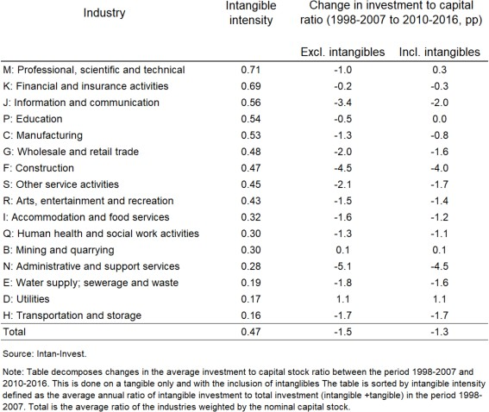

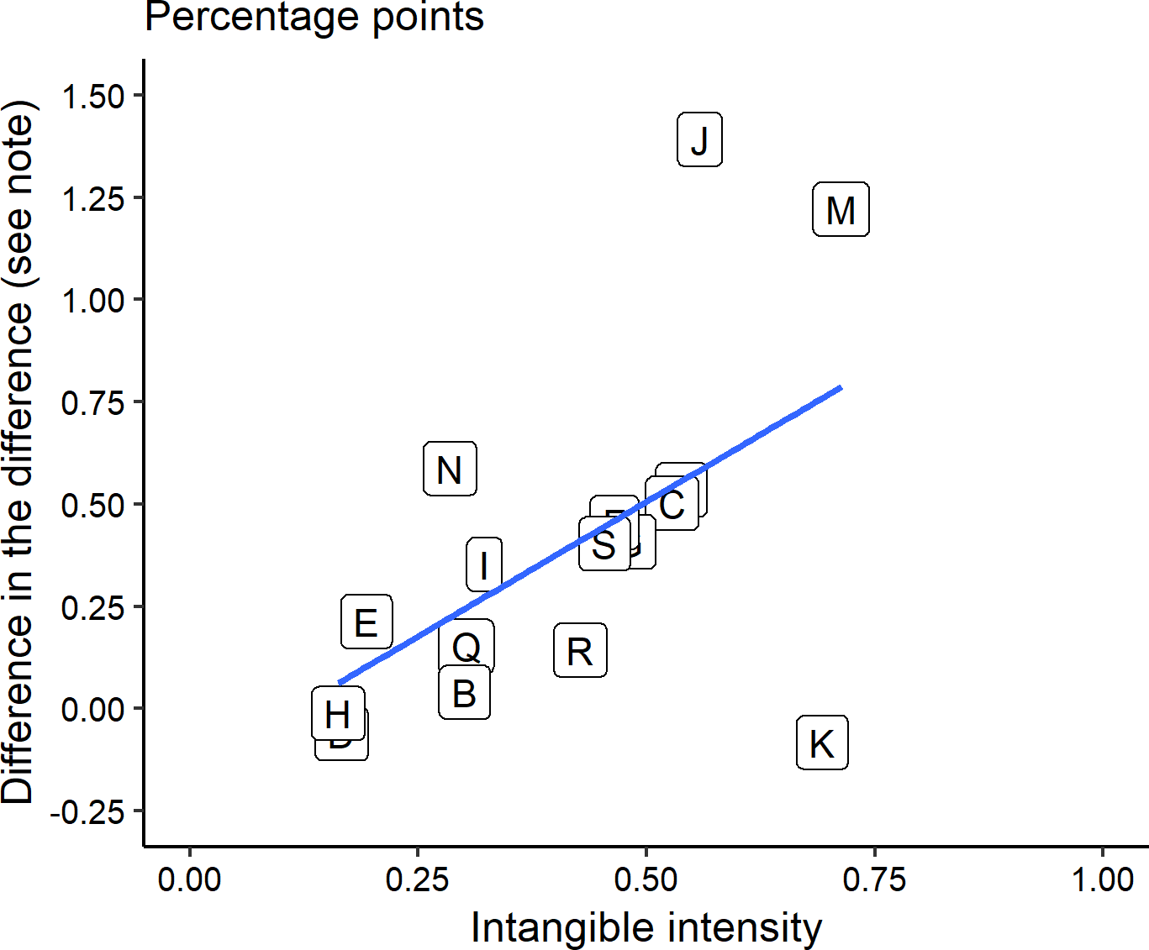**Figure 5 – Effect of capitalising intangibles on the change in the investment to capital stock ratio between the pre and post crisis period.**

Source: Intan-Invest.

Note: Figure shows the difference of difference in the pre (1998-2007) and post

financial crisis (2010-2016) average investment to capital stock ratios by industry with and without intangibles. A positive value implies that the ratio fell by less or

grew more when intangibles are capitalised and included in the calculation. See Table 3 for industry codes and descriptions. The blue line is the line of best fit.

# Conclusion

Today, I have outlined the long term trend away from an economy of tangible capital to one of intangible capital and how the categories and characteristics of intangible capital differ from tangible capital. It is a pleasure to have done so here in York where Rowntree used both tangible and intangible assets to successfully sell its products.

It is incumbent on economists to incorporate and understand this trend and assess whether our current models can capture the implications. I have focused on and outlined some of the challenges to measurement and highlighted where the omission of the measurement of intangible capital plays a role in active debates amongst policy makers concerning trends in margins, mark-ups, scale and investment.

I would reiterate that measurement is not the only channel we as policymakers need to pay close attention to.

For example, in my discussion of mark-ups I decomposed the mark-up into a scale component and a profit component, both are variables that could interact with and change the dynamics of output, wages and inflation. I also believe that through its intangible nature there are implications for the financing of business investment, particularly for new firms. Firms may have to shift more to equity financing and venture capital, while lenders may rely more on earnings-based loan covenants and less on collateral. There are implications for financial stability and monetary policy transmission but the overall balance of direction is not clear. This is an area for

future research.

Finally, let me thank you gain for your hospitality and Ken Dixon for supporting this lecture series.

# References

**Aquilante, T., Chowla, S., Dacic, N., Haldane, A., Masolo, R., Schneider, P., & Tatomir, S. (2019**). ‘Market power and monetary policy’. *Bank of England Staff Working Paper* No. 798.

**Barkai, S. (2016). ‘**Declining labor and capital shares’. *Stigler Center for the Study of the Economy and the State* New Working Paper Series, 2.

**Basu, S., and Fernald, J. (2001)**. ‘Why is productivity procyclical? Why do we care?’. In *New developments in productivity analysis* (pp. 225-302). University of Chicago Press.

**Corrado, C., Jager, K. and Jona-Lasinio, Cecilia. (2016). ’**Measuring intangible capital in the public sector: A manual’. *Instituto Valenciano de Investigaciones Económicas*, S.A.

**Crouzet, N., and Eberly, J. (2018).** ‘Understanding weak capital investment: The role of market concentration and intangibles’. Prepared for the *Jackson Hole Economic Policy Symposium*.

**Cunliffe, Sir Jon. (2017).** ‘Are firms underinvesting – and if so why?’. Speech given at *Greater Birmingham Chamber of Commerce* on 8 February 2017.

**De Loecker, J., and Eeckhout, J. (2018).** ‘Global market power’. *National Bureau of Economic Research. Working Paper* No. 24768.

**Ellert, J., Hyde, D. and Killing, J.P**. (1991). ‘The Nestle Takeover of Rowntree: A Case Study’. *European Management Journal*, (9), pp. 1-17.

**Fitzgerald, Robert.** (2007). ‘Rowntree and the Marketing Revolution, 1862-1962’*. Cambridge University Press*.

**Hall, R. E., & Jorgenson, D. W. (1967).** ‘Tax policy and investment behaviour’. *American Economic Review*

57(3), 391-414.

**Hall, Robert E. 2018.** ‘New Evidence on Market Power, Profit, Concentration, and the Role of Mega-Firms in the US Economy.’ *NBER Working Paper* No. 24574.

**Lipscomb, A.A. and Bergh, A.E. (eds).** (1905). ‘The Writing of Thomas Jefferson’. *Thomas Jefferson Memorial Association*, 13:333-35.

**Mather, P.R., and Peasnell, K.V.** ‘An Examination of the Economic Circumstances Surrounding Decisions to Capitalize Brands’. *British Journal of Management*, (2), pp. 151-164.

**McCafferty, I. (2014).** ‘Achieving a sustainable recovery: where next for business investment?’. Speech given at

*Nottingham Business School* on 22nd January 2014.

**Syverson, C. (2019).** ‘Macroeconomics and Market Power: Facts, Potential Explanations and Open Questions’. *Brookings Economic Studies Report*.

**Tenreyro, Silvana (2018).** ‘The fall in productivity growth: causes and implications’. *Peston Lecture at Queen Mary University of London* on 15 January 2018.